Practical No : 05

**Practical Title:** Setup your own cloud for Software as a Service (SaaS) over the existing LAN in your laboratory. In this assignment you have to write your own code for cloud controller using open-source technologies to implement with HDFS. Implement the basic operations may be like to divide the file in segments/blocks and upload/ download file on/from cloud in encrypted form.

# Objectives:

* To set your own cloud for SaaS over existing LAN
* To implement the basic operations may be like to divide the file in segments/blocks

# Hardware Requirements :

* + Pentium IV with latest configuration

# Software Requirements :

* + Ubuntu 20.04, VMwareESXi cloud

# Theory:

Here we are installing VMwareESXi cloud

* + - Host/NodeESXi installation:-
    - **ESXiHardwareRequirements:-**
* ESXi6.7requiresahostmachinewithatleasttwoCPUcores.
* ESXi6.7supports64-bitx86processors
* ESXi6.7requirestheNX/XDbit to be enabled for the CPU in the BIOS.
* ESXi6.7requiresaminimumof4GBofphysicalRAM.Itisrecommended to provide atleast 8 GB of RAM to run virtual machines in typical productionenvironments.
* Tosupport64-bitvirtualmachines,support for hardware virtualization (IntelVT-xor AMDRVI) mustbeenabledonx64CPUs.
* One or more Gigabit or faster Ethernet controllers. For a list of supportednetwork adapter models.
* SCSI disk oralocal,non-network,RAIDLUN with unpartitioned space for the virtualmachines.

ForSerialATA(SATA), a disk connected through supported SAS controller or supported on board SATA controllers. SATA disks are considered remote not local. These disks are not used as a scratch partition by default be cause they are seen as remote.

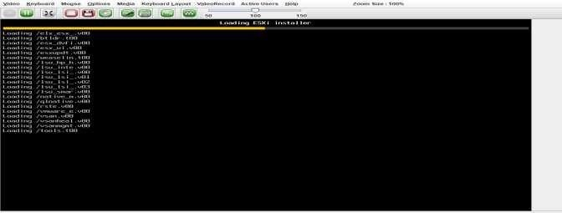

**ESXiInstaller: Accept Agreement:**

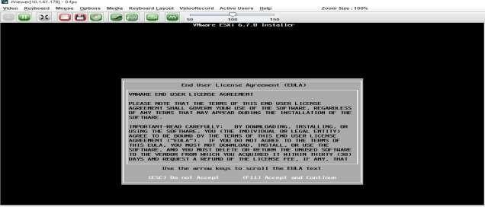

# Select storage :



**Select Keyboard Layout :**



# Set NodeESXi Root Password :



**Installation complete (Reboot)CLII interface to configuration**

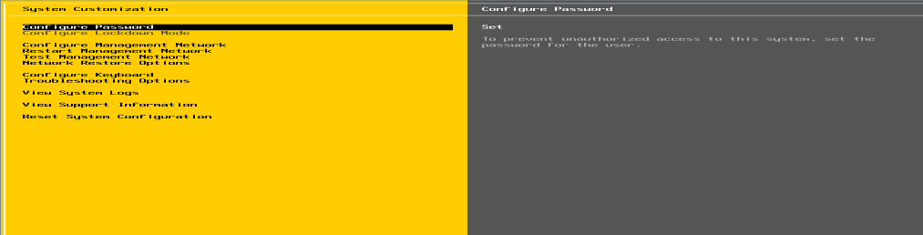

# CLI Interface to Configuration:

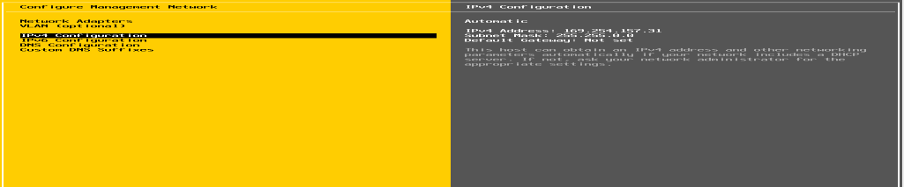

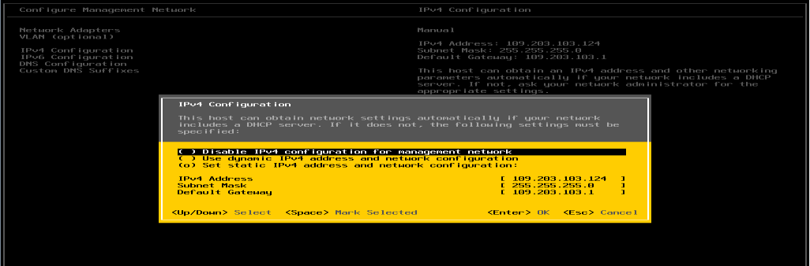**Configure Management Network**

# Set IPV4

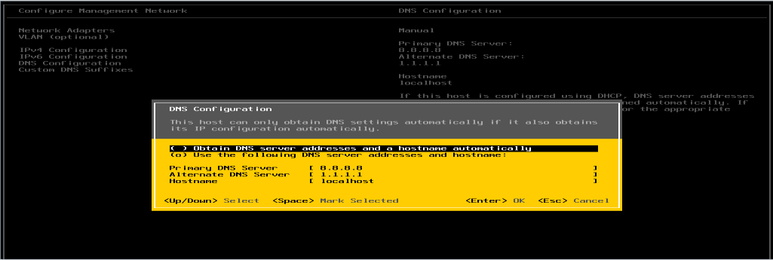

**Set DNSeriver :**

# Restart Management Network

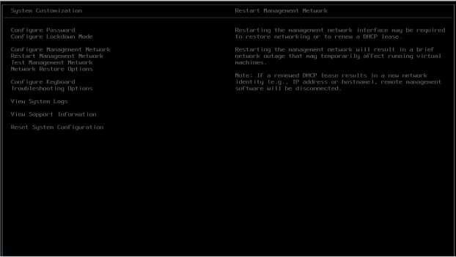

**GUIAccess :**

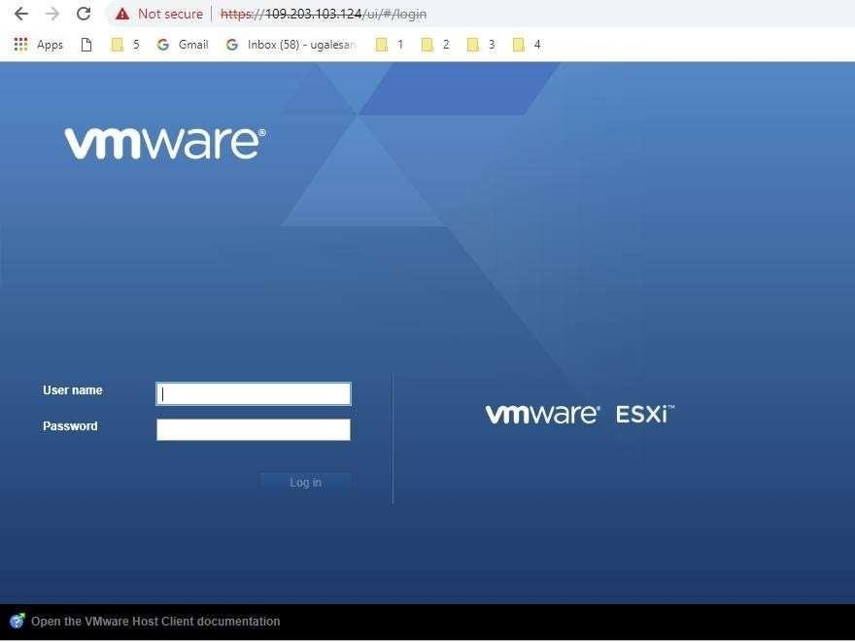

# ClusterSetup

* **CreatingDatacenter**

# CreatingCluster

* **Adding Hosts incluster**

# Resourcesafteraddingcluster.

* **DRS**

# Failover

**VCenter Access:**

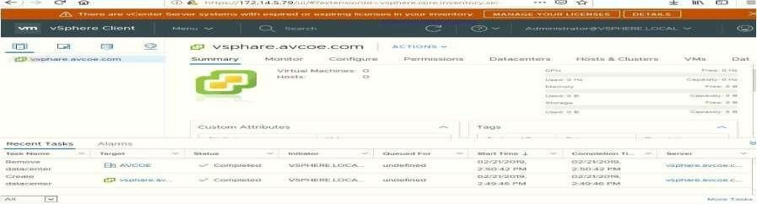

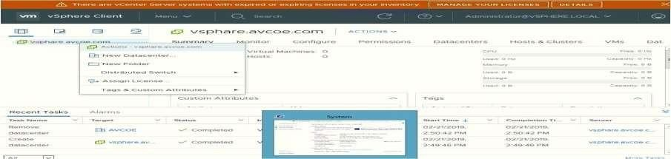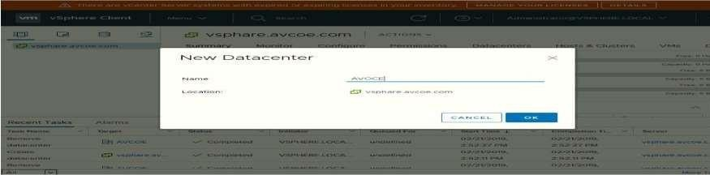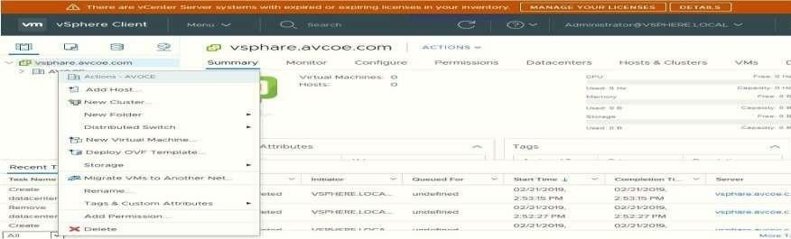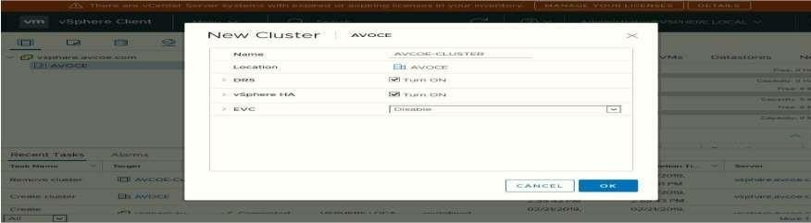

# Create Datacenter:

**Create cluster : Assign cluster name :**

***MET’s BKC Institute of Engineering, Nashik. Prof. Anand N. Gharu***

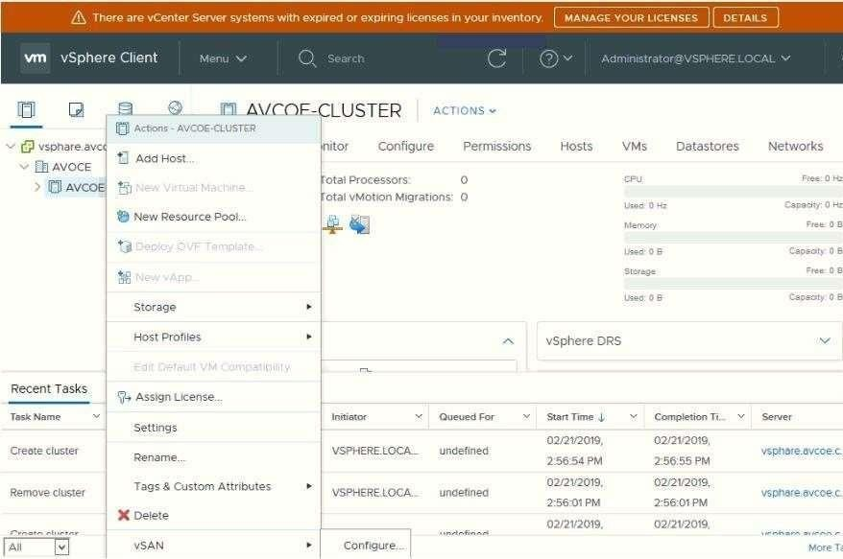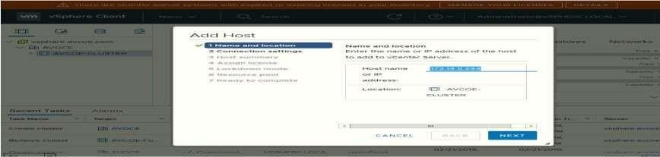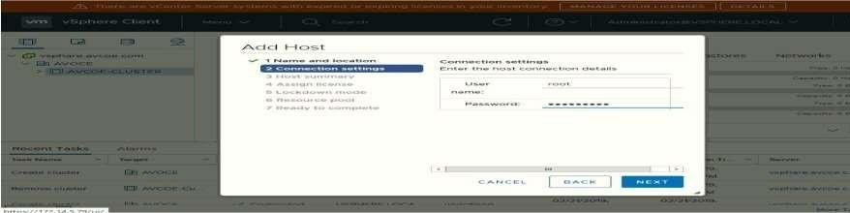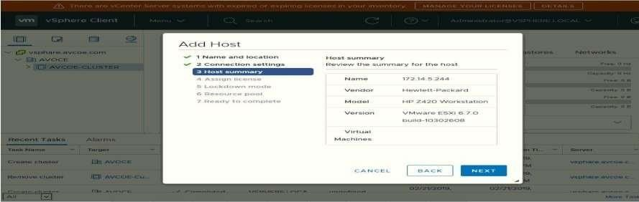

# Add host .:

**Add host IP :**

# Enter host credential :

***MET’s BKC Institute of Engineering, Nashik. Prof. Anand N. Gharu***

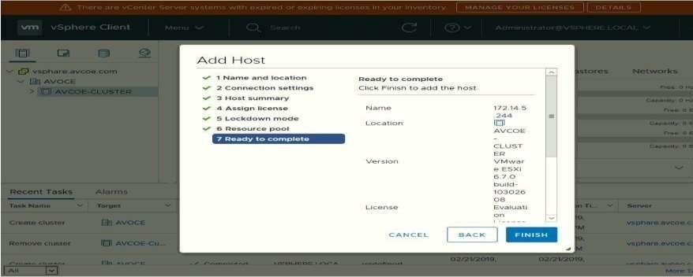

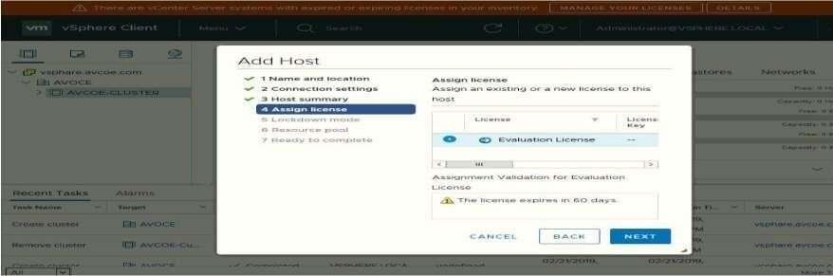

# Hot summary : Lock Down mode:

**Add Host In Pool:**

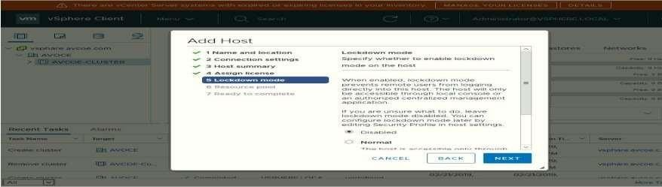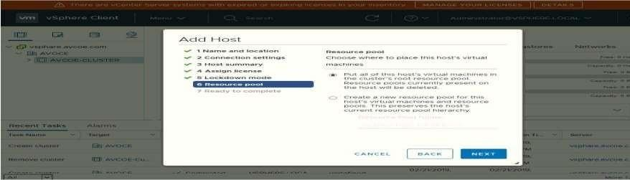

# Finish:

**Host View and View Config:**

# Cluster View and Configuration:

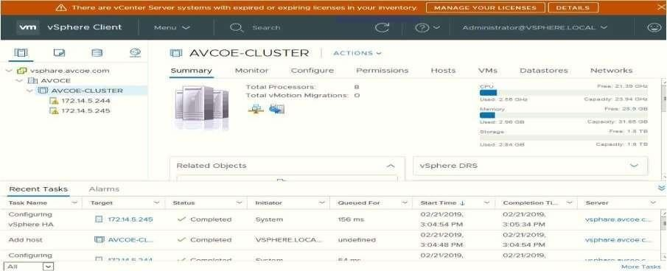

**Conclusion:** Like this we have configure VSphere Private Cloud